OpenERV WM12 manual

BETA V1.0

Introduction:
The WM12 is essentially just two TW4 energy recovery ventilator (ERV) modules, with a few electronic parts missing to reduce the cost, and a foam adapter.

The TW4 energy recovery ventilator is meant to be a unit that is embedded in a wall, to provide long term highly effective energy recovery ventilation i.e. capture the heat and water vapor contained in outgoing ventilation air, and transfer it to incoming ventilation air.

In the WM12, the foam, timber and hardware takes the place of the wall.

The TW4 modules are carefully designed to do this with high efficiency and far lower low noise than anything else that does anything similar.

They include highly sensitive and accurate pressure sensors to regulate the air pressure across the heat exchanger, thus regulating airflow into and out of the house despite the chimney effect, wind, etc.

It’s important to note that the unit is still in beta, and the modules can be flexibly configured in many ways. This may appear to complicate things but allows people to get what they need for longer term.

The machine is fundamentally capable of working to either prevent heat and water vapor intrusion during periods of air conditioning, or prevent the escape of heat during periods of heating, but the focus at first is on cold climates, because parts that can stand high temperatures encountered in hot climates are more expensive to make. The polymer currently used for some of the additively manufactured parts starts to get soft at 55 degrees C.

The WM12 can be controlled over WiFi using MQTT but it requires some setup.

You can find the manual for the TW4 ERV here, where the WiFi related features etc are discussed: https://docs.google.com/document/d/1owr_riiIEUlUa45al_b7uIGe7IZfdDO1xxAAJC9aKUU/edit?usp=sharing

General points to be aware of:
- The silica gel coated heat exchangers may appear to have a smell upon first use *this is because they adsorb harmless chemicals from the packaging etc.*. These chemicals are no more harmful than they are otherwise, but you can smell them primarily because they are added to otherwise fresh air, the smell is not covered up by other smells. There can only be so many milligrams of stuff adsorbed by the silica gel, and eventually it must all come out, or stay stuck in there. The smell should dissipate after a few days of operation, giving you perfectly clean outdoor air from then on. The material used in manufacture is non-toxic bio-source PLA, silica gel and isopropyl alcohol. There are no toxic substances used.
- Don’t pull on the wires significantly, they don’t have any strain relief, except the power wires.
- Remember Energy Recovery Ventilation is a long term value proposition. Although this machine has a remarkably fast payoff period as energy investments, or any investment, goes (less than 2 years on some contexts), it is meant to last a very long time. Be careful with it, position it in a place you are comfortable with the noise it produces, and ideally on a side of the house with minimal outdoor noise and wind. The components can be re-used to build a pair of TW4s for permanent installation in a dwelling for very long term, or re-sold while retaining their value. Additively manufactured/3d printed parts are not cheap or temporary, they can last a very long time and are relatively costly to produce.
- The unit is capable of high airflow, 60 cfm is enough fresh air for a whole house by some measures. Most ERV units that advertise higher airflows will be revealed to not give anywhere near that in real world conditions if you actually check the manual/test data. A $3000 large centralized unit in the basement of a house is only made to do about 60 CFM during very cold weather, and it doesn’t get very good efficiency, either, under such conditions.
- The system is quieter by far at any given airflow than similar push-pull units and centralized units, or any other ERV. It’s also directly in the living space, however.
- It may seem that the air exiting the unit is cold, if you put your hand in the air stream. However, remember that any air colder than the surface of your hand will feel colder still if it is moving than if it is not. For comparison, try turning on a fan in a room, and you see the air exiting the fan feels colder. It is not, of course, any colder. Its temperature did not go down as it passed through the fan. We judge how cold things feel by the temperature of our hand, and how fast it changes. The faster the air is moving, the faster it extracts heat from our hand, and the lower the equilibrium temperature of our hand would be, should we leave it in the air stream long enough.
- If you wish to test/check the efficiency of the unit, a method using a low cost infrared thermometer is described elsewhere in this manual.
- The system takes a while to adjust the power level after the knob is adjusted. You will hear it adjusting but it takes a minute or two to adapt to large changes.
- Do not drop the unit, the printed parts are not strong enough to stand such forces. They can of course be replaced, all parts of the system can be replaced, but the labor and cost is significant. The machine is an investment. Treat it like a desktop PC when you are moving it, etc. Pick it up carefully with both hands, plan where you are going to put it ahead of time, unplug all cables before moving it, etc.
- The wind compensation similarly takes 30 seconds or more to fully respond, thus it is not effective in random gusty weather to block gusts, except to compensate for the average pressure.
- The beta units are made of MPLA. It is only good to 55 degrees C. The parts are not made for very hot ambient temperatures combined with direct sunlight. That will be addressed after proving everything in cold climates where such conditions are never encountered.

Options to be aware of:
- Silica gel coating of heat exchangers. If it has a matte texture, it’s coated with silica gel, which serves to absorb water vapor from outgoing air and transfer it to incoming air. This represents heat energy in some ways, because if there is lower humidity in incoming air, it accelerates the evaporation of water in the dwelling, and when water evaporates it absorbs a great deal of heat. The silica gel is the same material used in food packaging, it is non toxic and completely harmless. Very small amounts might come off on your hands, it is as harmless as sand.
- The outdoor plate and hood unit allows the adaption of filters and the storm valve attachment, however recent changes with the sound splitter on the outdoor side have messed things up and I have not yet figured out how to use them in combination with the sound splitter in a window mount context/WM12. The old version with the plate and hoods and the fans inside the pipe is still an option if anyone needs the filter or storm valve modules while also mounting everything in a window.
- There are many strange and terrible permutations and reorganizations of components that are possible, especially with the wireless features of the TW4, you can put the two halves in different windows in different rooms etc, but I have not experimented much with this.
- The WM12 can be rotated and mounted sideways if the window is a shape that requires this, a window restrictor clamp should be used if this is done, to ensure it cannot fall out of the window.

Things during beta to be aware of:
- The initial units are made for cold climates primarily, extreme heat encountered in a desert could damage some components.
- Extreme heat has to be avoided during shipping, too.
- The firmware is the exact same as the Leader of a pair of TW4 units. It has an auxiliary output for the second set of fans in the WM12, which is still active but not connected in a TW4 leader. In a WM12, only one side has a pressure sensor.
- I don’t know for sure what will happen during extremely cold weather, like minus 30 C. Probably things will be fine, especially with the silica coated heat exchangers. It is very difficult to test. Simulations and calculations indicate some safety margin. However it is possible frost could accumulate on the heat exchanger or fan. This could cause temporary issues. The solution is to allow hot air from the house to exit the unit, melt the frost and evaporate the water, then start again. There are no provisions in the firmware for this right now. If the fans become stuck, you would have to take it out of the window, let it melt and dry and then put it back. The fans are waterproof. Future firmware updates may include functionality to detect cloggage with the pressure sensor and execute a defrost routine.
- The pressure detected by the pressure sensor is actually the pressure divided by about 4. This is because the pressure drops as the air flows through the narrow silicone tube, the sensor is not actually sealed and some air flows through it, however it still works very well. The pressure is divided in a repeatable and precise way, like a resistive divider dividing voltage, basically. Do not constrict the tube, or that would change things.

Post-shipping assembly:
Consult the images to get an idea of how it goes together. Then, I recommend the following approximate procedure, there are likely to be details specific to your situation.

Tools probably required:
- Ball end hex drivers, 2.5 mm and 3 mm, for the bolts and screws.
- Saw for wood
- You may or may not need a flat end screw driver, some of the clamps use hand-tightenable type mechanisms, some the screw head type.
- Some books or something else to prop it up on a table
- A table to work on for post shipping assembly.
- Box cutter with brand new/sharp blade to cut the foam.
- Sharpie to mark the foam and timber before cutting.
- Transparent or regular tuck tape (to attach the optional extra green pipe segments on the outdoor side) (some may be included, wrapped around the pipe segments).

Part names:

Heat exchangers:
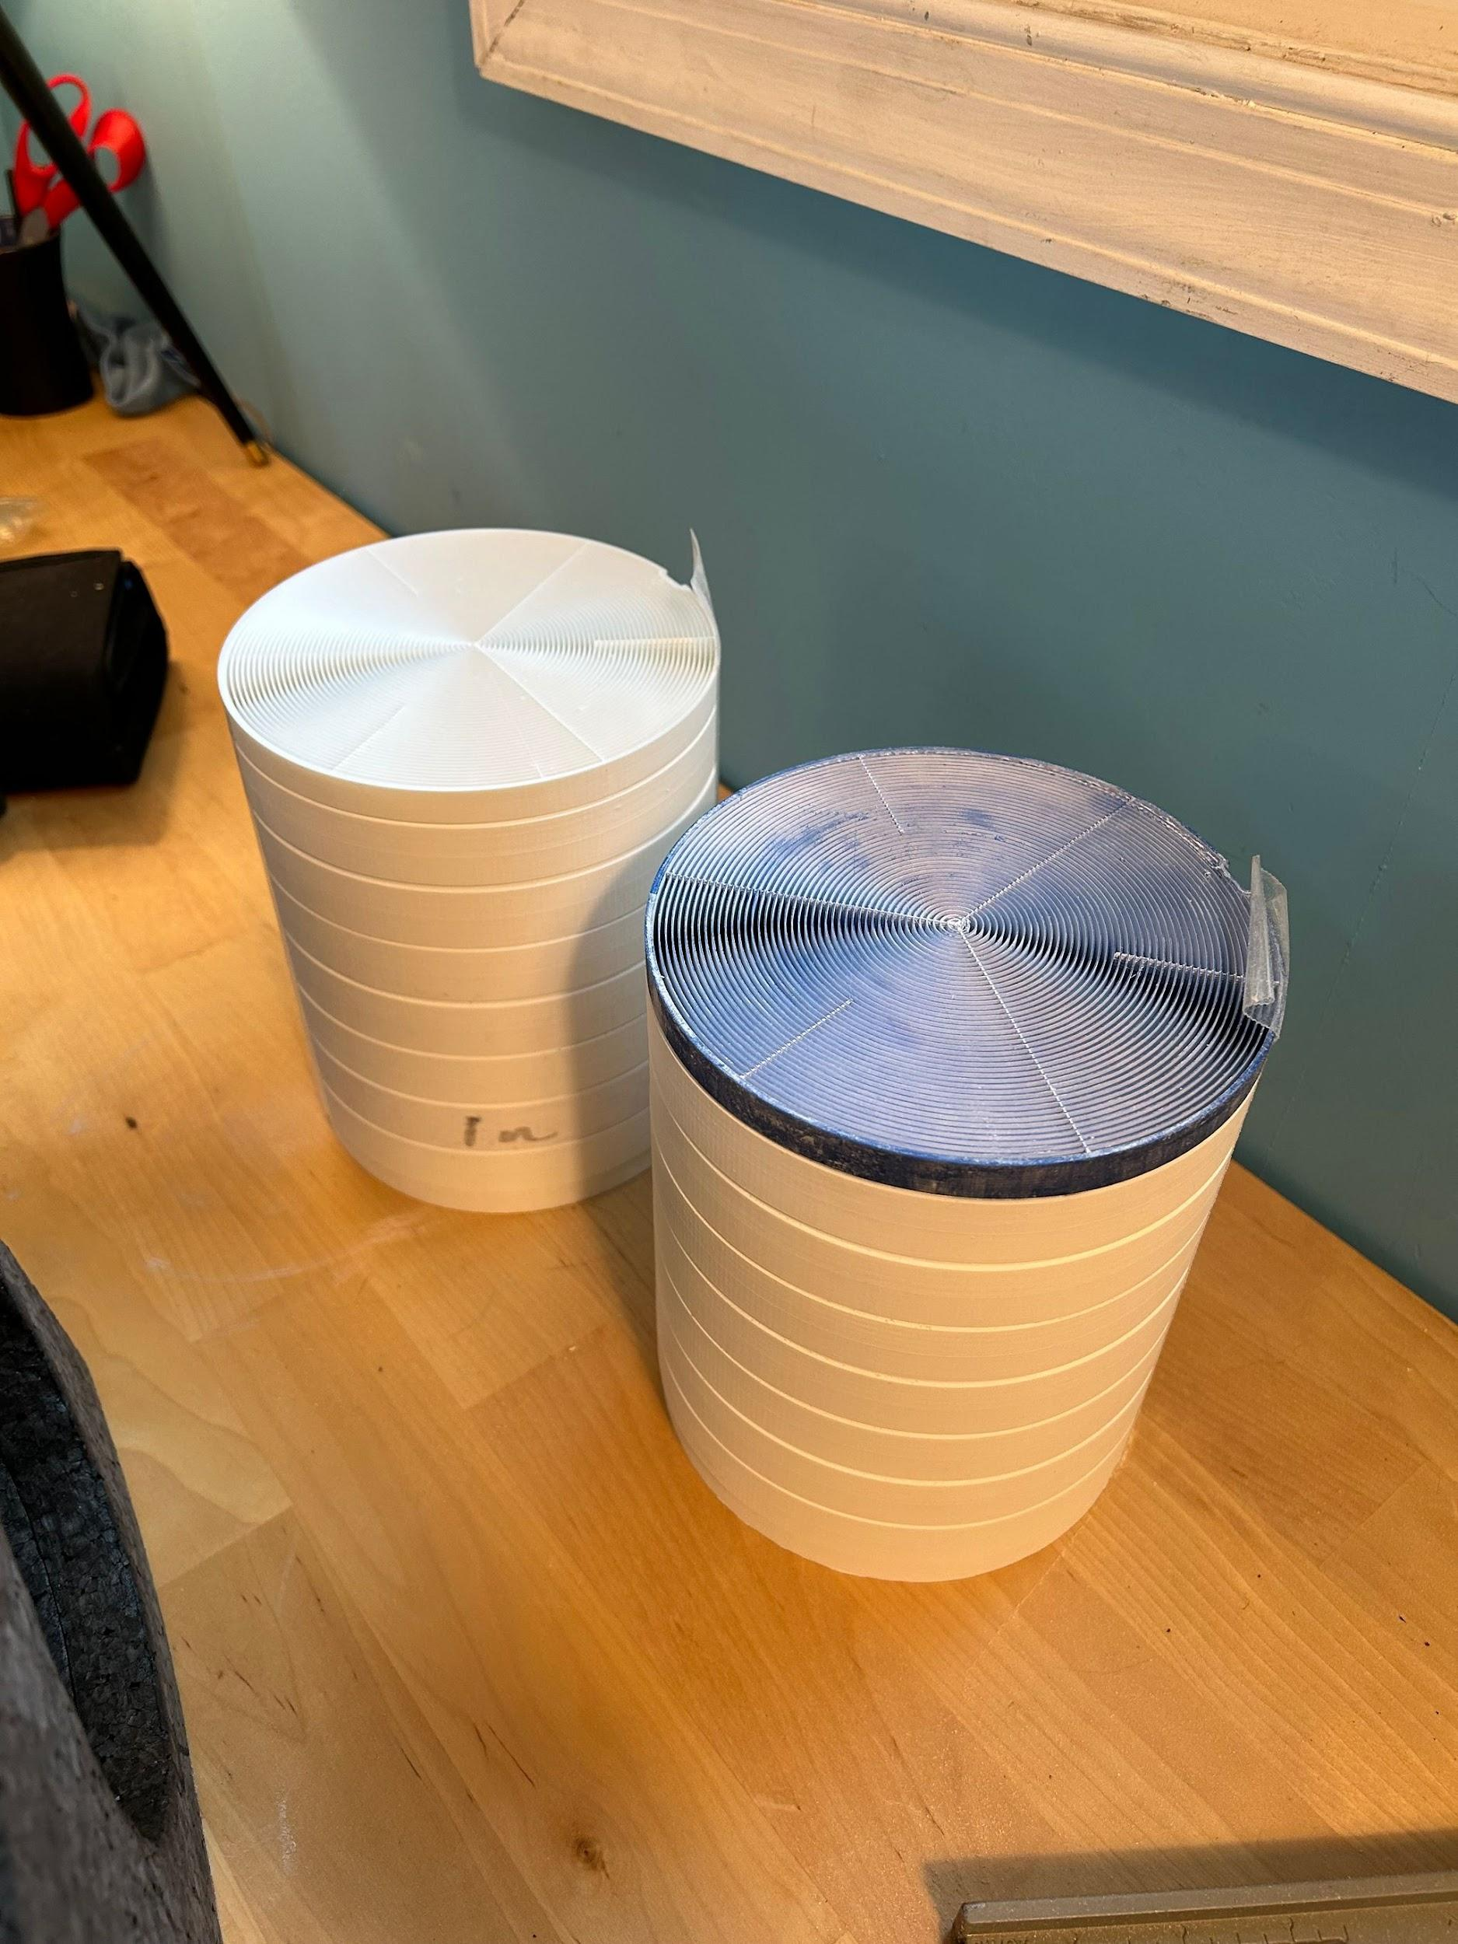

Noise splitter:
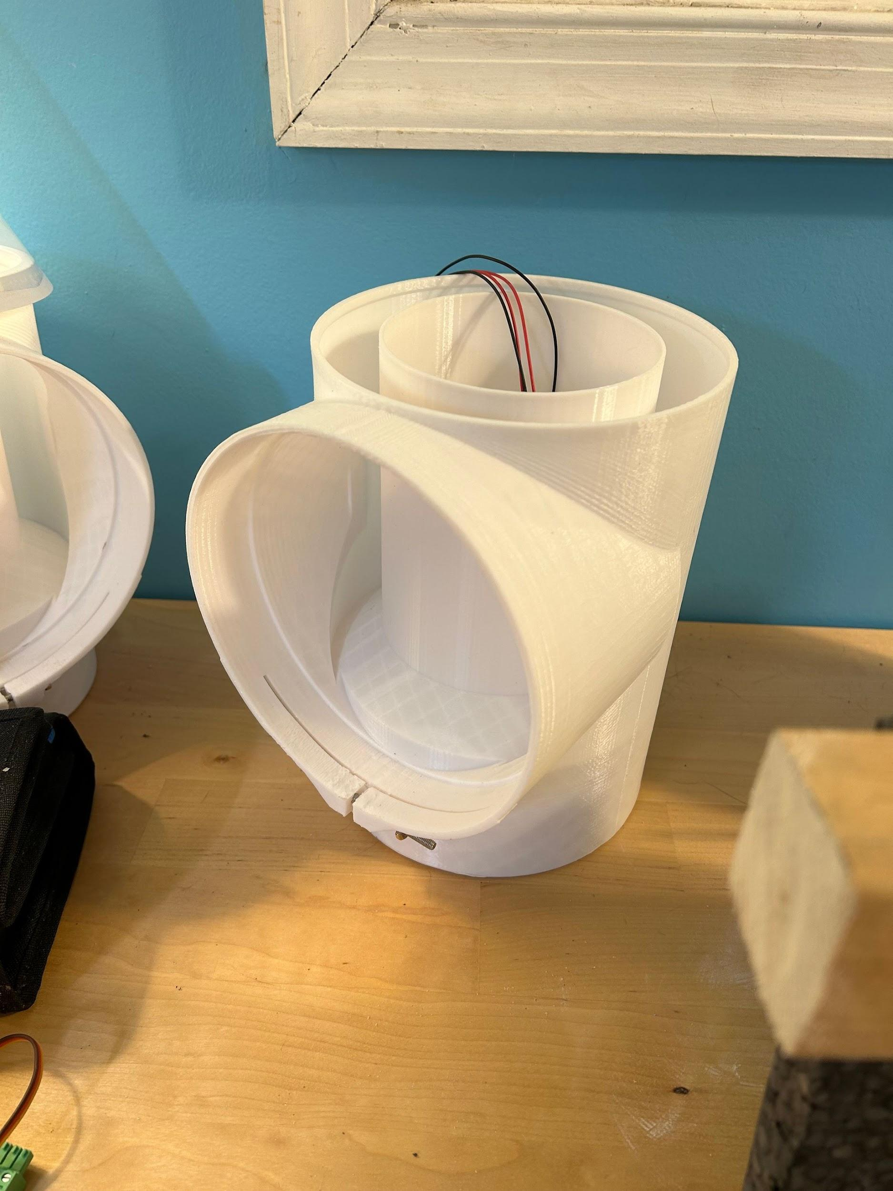

Mylar hat:
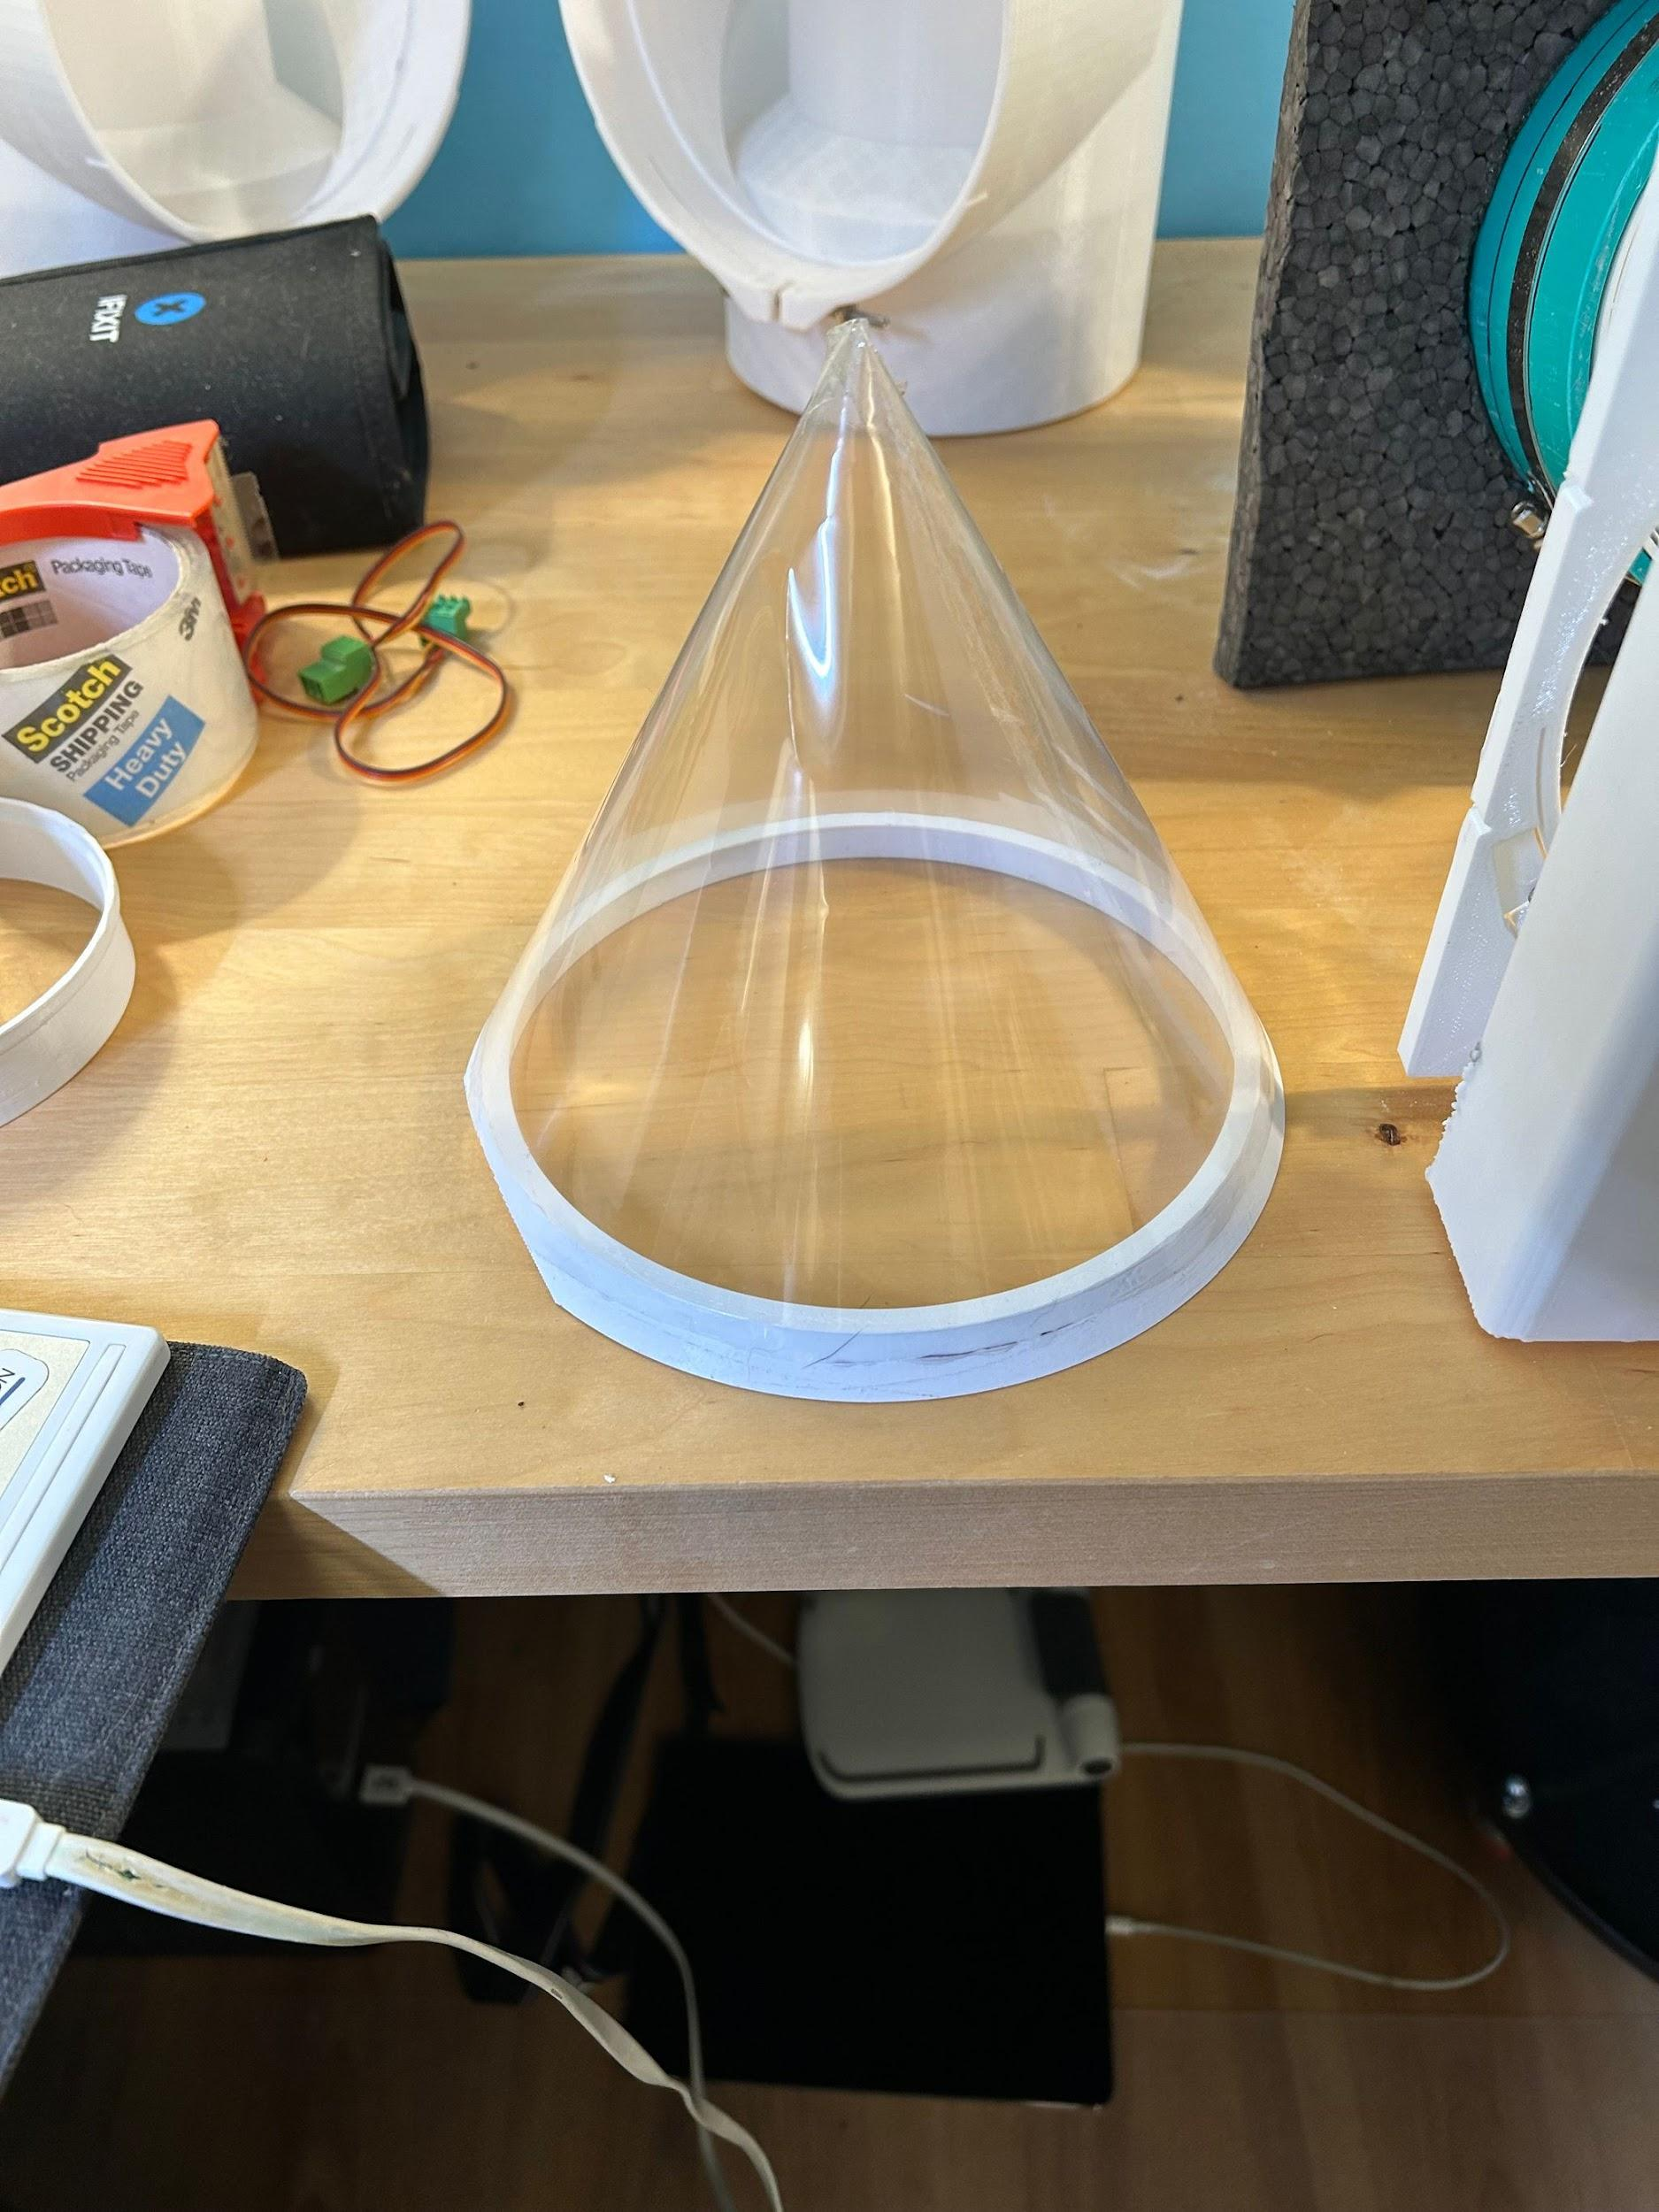

Noise splitter pipe extensions:
These extend the central pipe, reducing noise, they are not integral because it gets too big to print, for now.
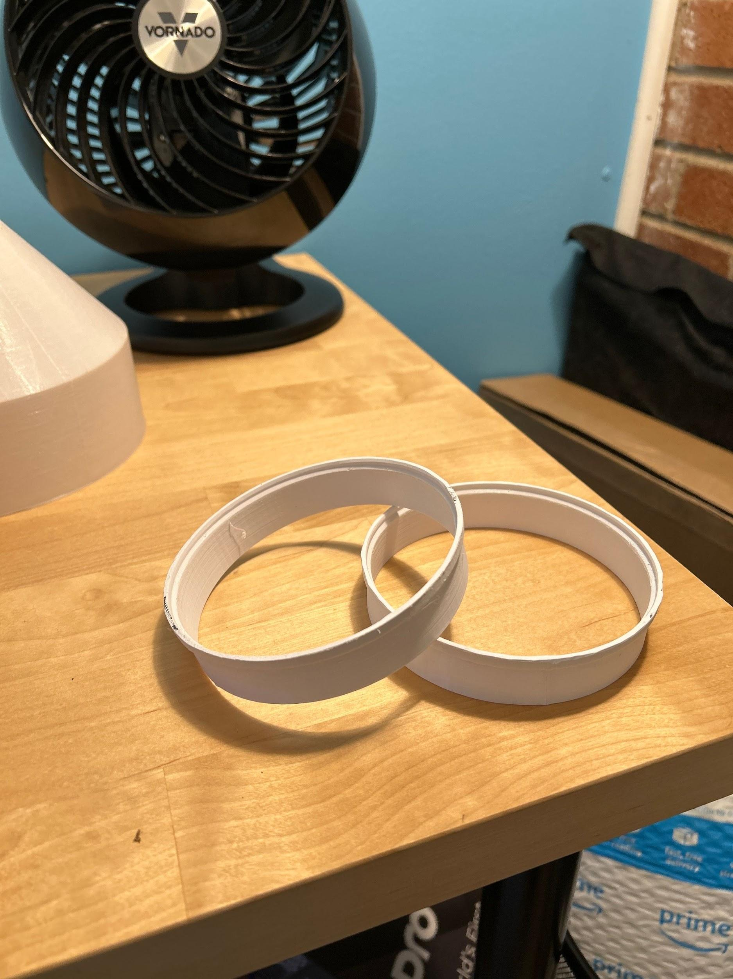

Wire extensions:
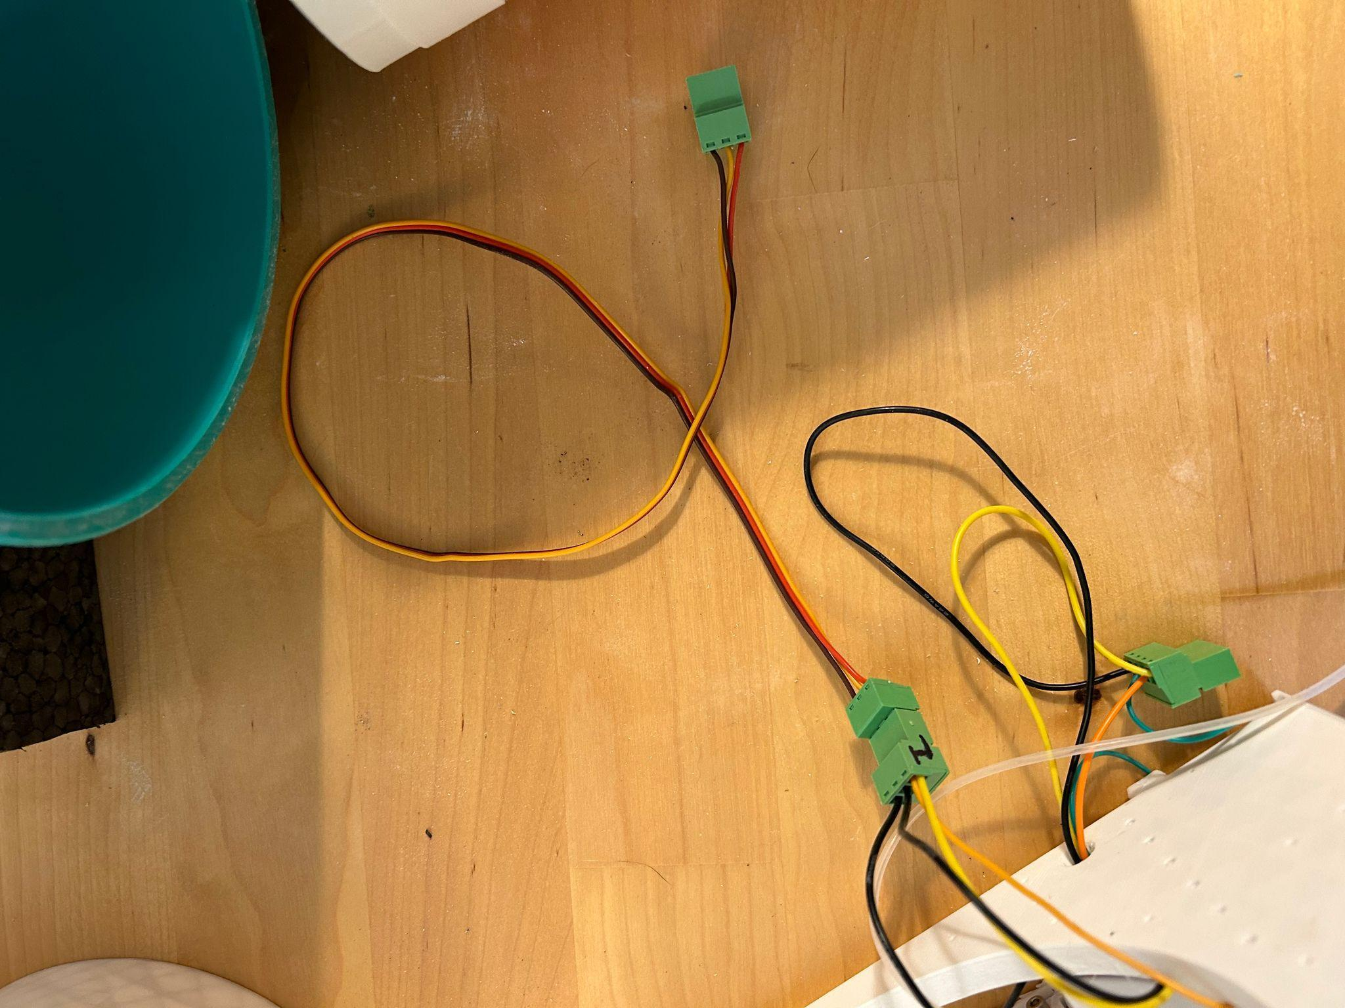

Main pipe:

Extra green pipe segment(s) for noise splitter (optional, reduces noise that comes in through the black foam by redirecting it downwards):
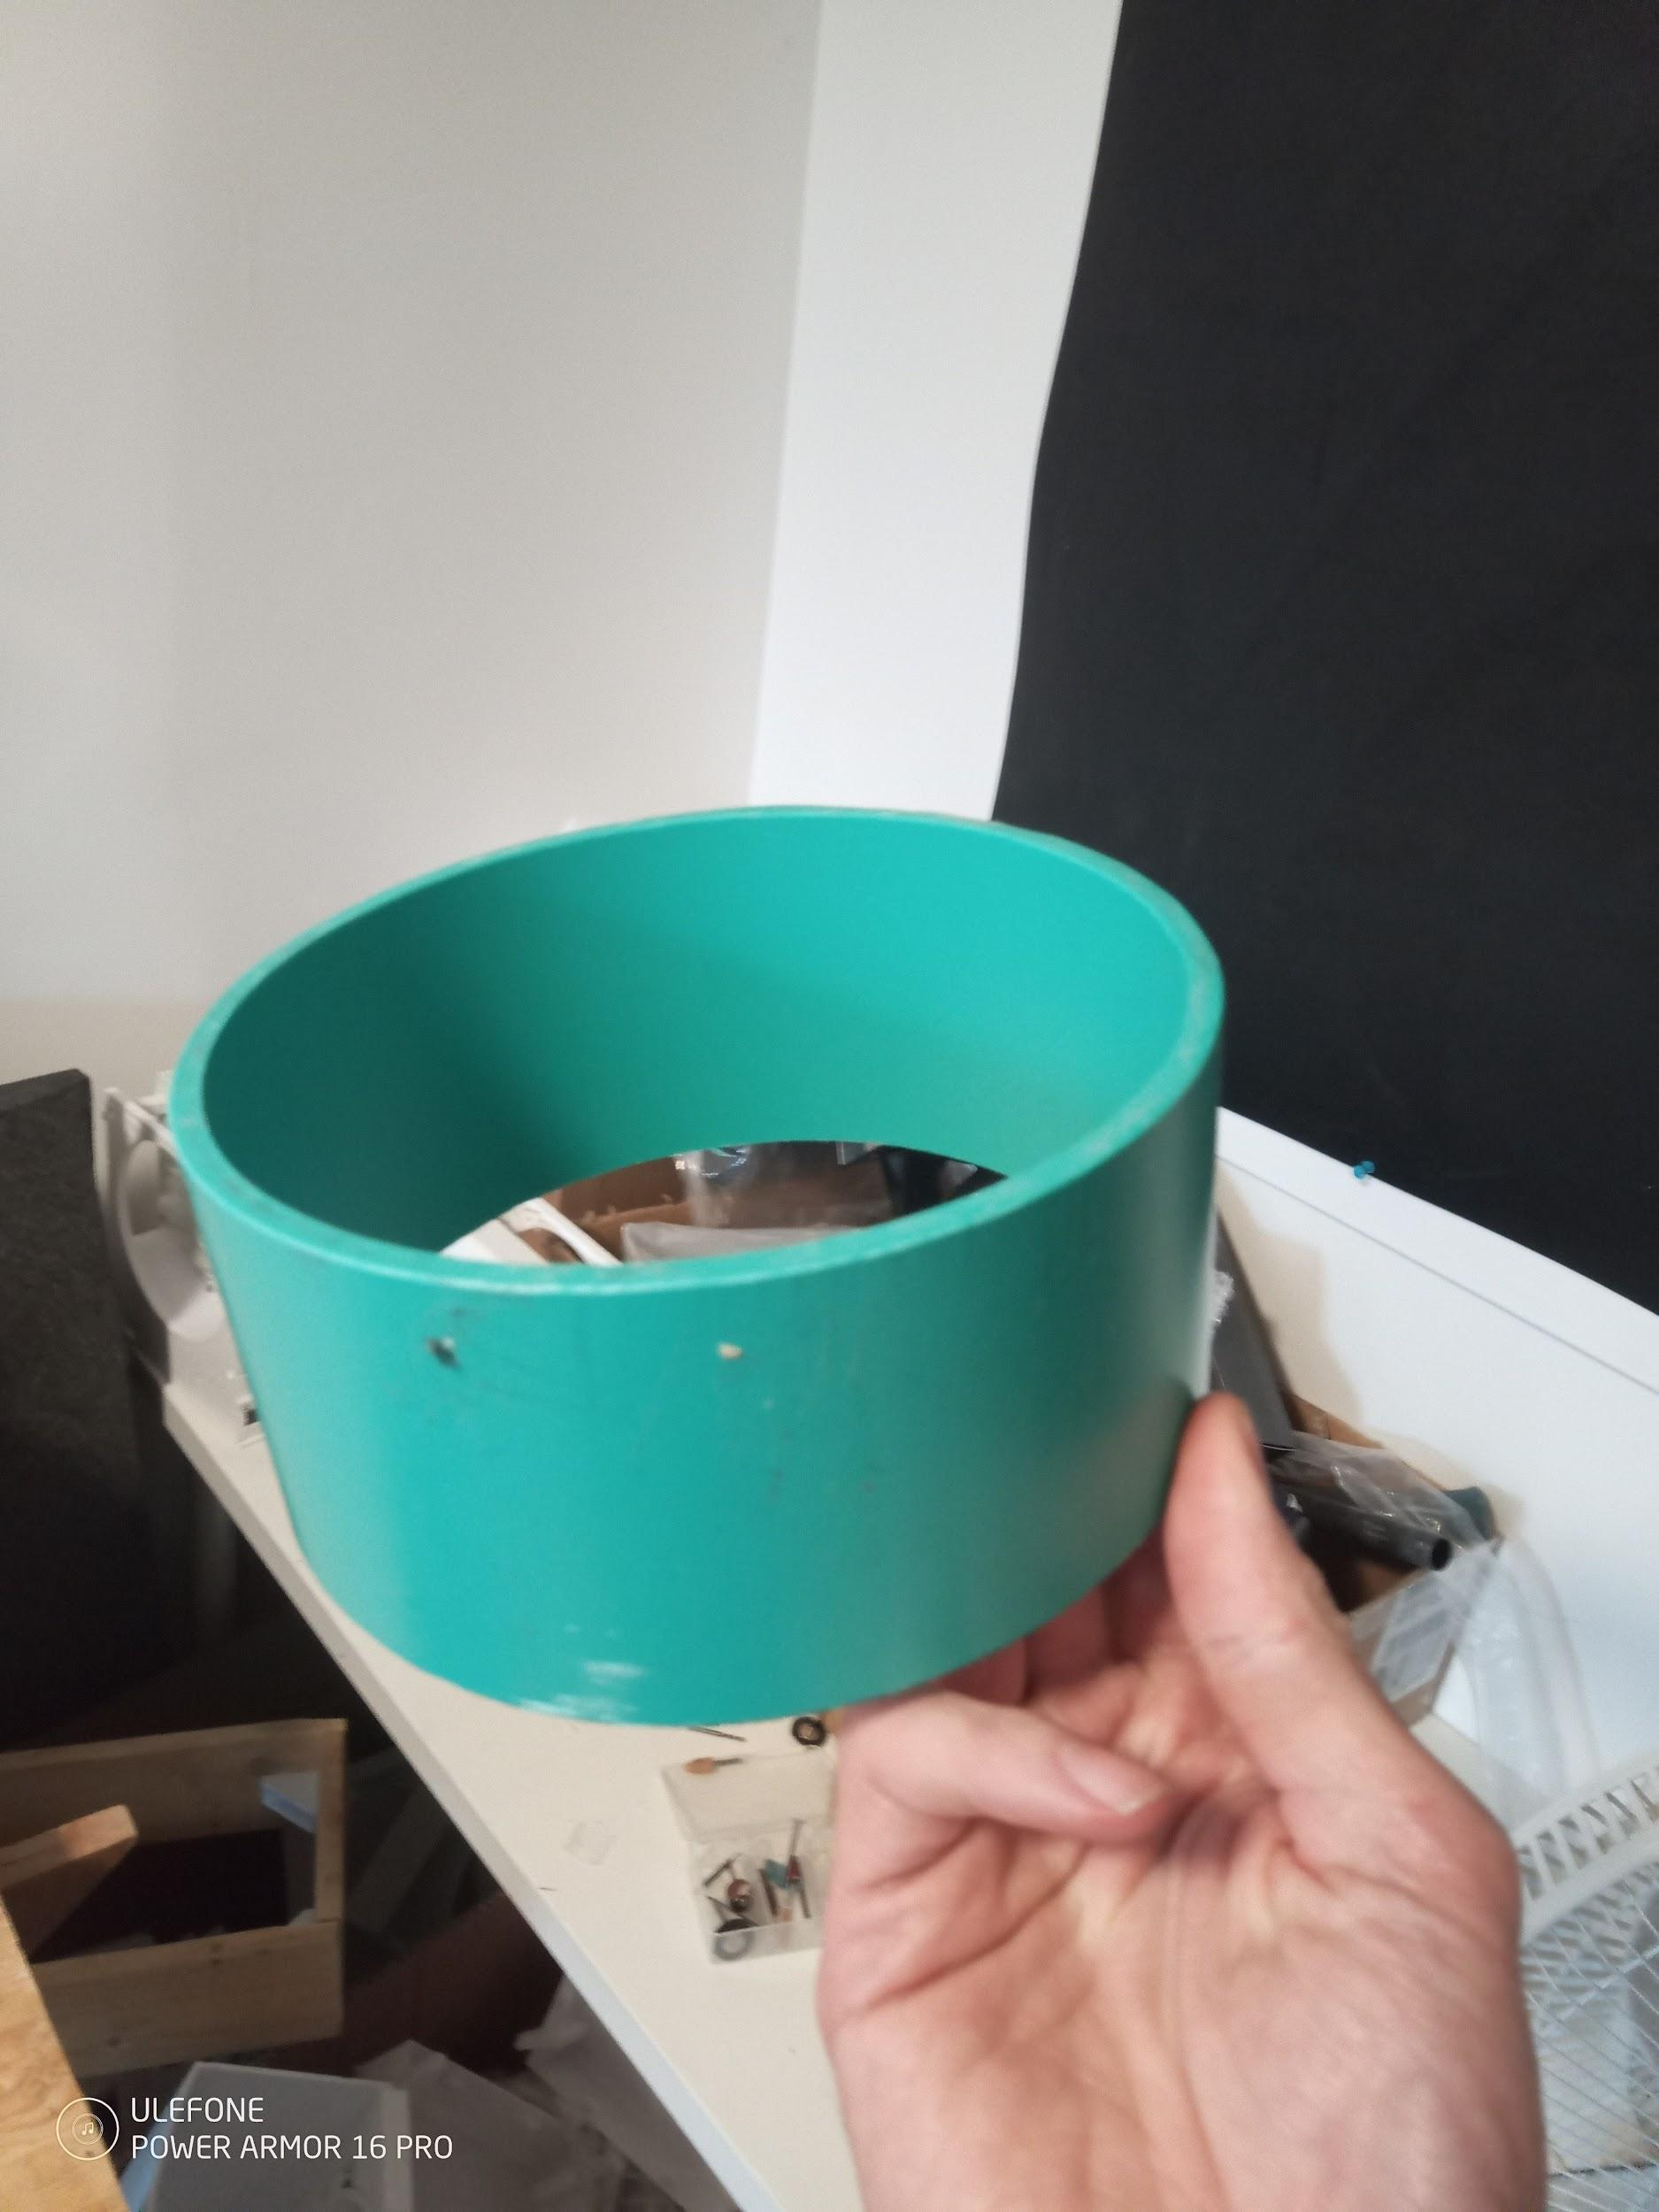

Indoor cover and plate assembly, with pressure sensor:
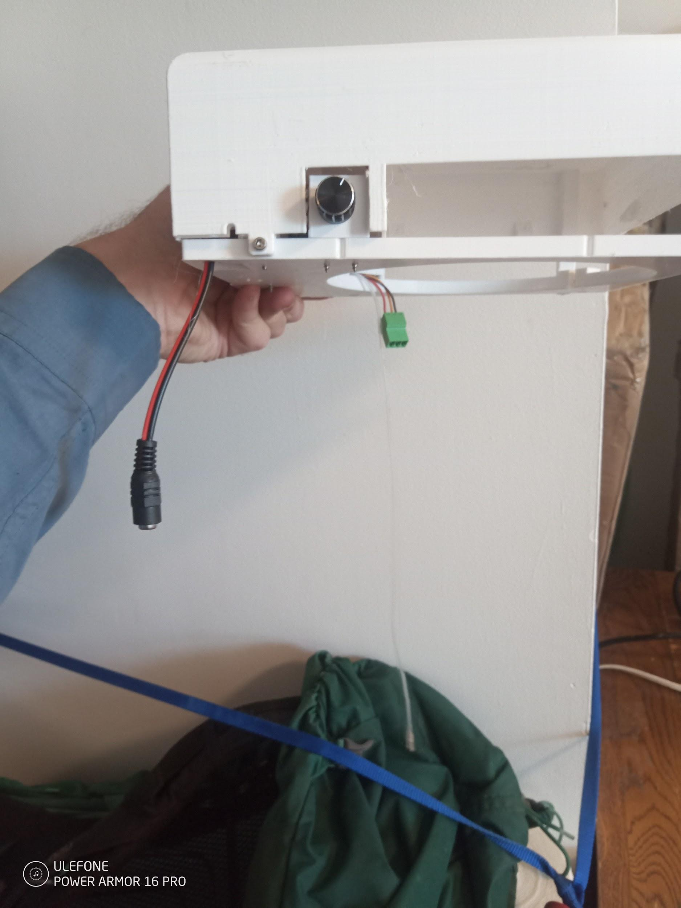

Indoor Plate and cover assembly with only 2 mosfet switches
Similar in appearance to the other cover/plate assembly.

Black foam adapter

Timber with hose clamps
This secures the pipes, acts as a handle and retains everything in the window securely.

Assembly procedure:
- Have a look at your window hold one of the main pipes in position, and, optionally, put the noise splitter on the pipe and have a look at how things are going to fit in the window. The timber should go across the window opening and then some, to make it practically impossible for the machine to fall out the window.
- Attach the clamps to the timber, and insert the pipes into the hose clamps, loosely. Have a look at how things are likely to fit in the window. Is there room for everything?
- Add the foam by pushing it onto the pipes
- 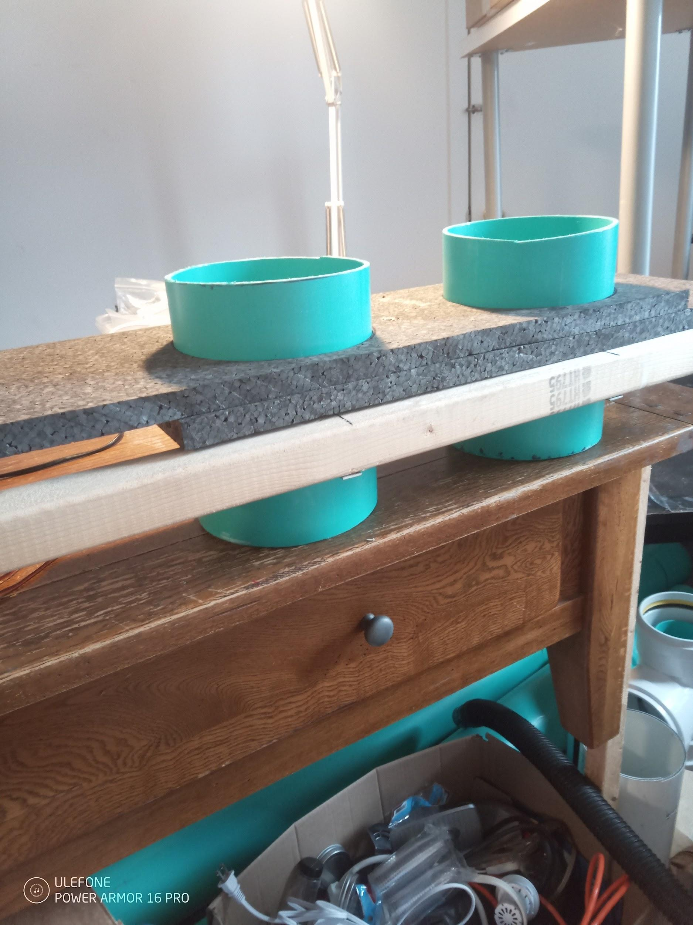
- Make sure the ends of the pipes are more or less flush with each other.
- See if it fits in the window ok, decide how to trim the pipes and timber. Mark with a marker or pen or pencil where to cut. See if you have room to add the little green pipe segments on the outdoor side. You can put the noise splitter on temporarily to check for fit.
- Trim the timber and the foam with a sharp box cutter for the foam and a saw for the timber. I used an oscillating saw so I don’t have to take the timber off in order to brace it while cutting. You may need to remove the pipes from the clamps and brace the timber to cut it safely.
- Attach the extension wires to the connector coming out of the noise splitter.
- Attach the noise splitters. Get them in position and tighten the clamps on them.
- Put the hats on the top.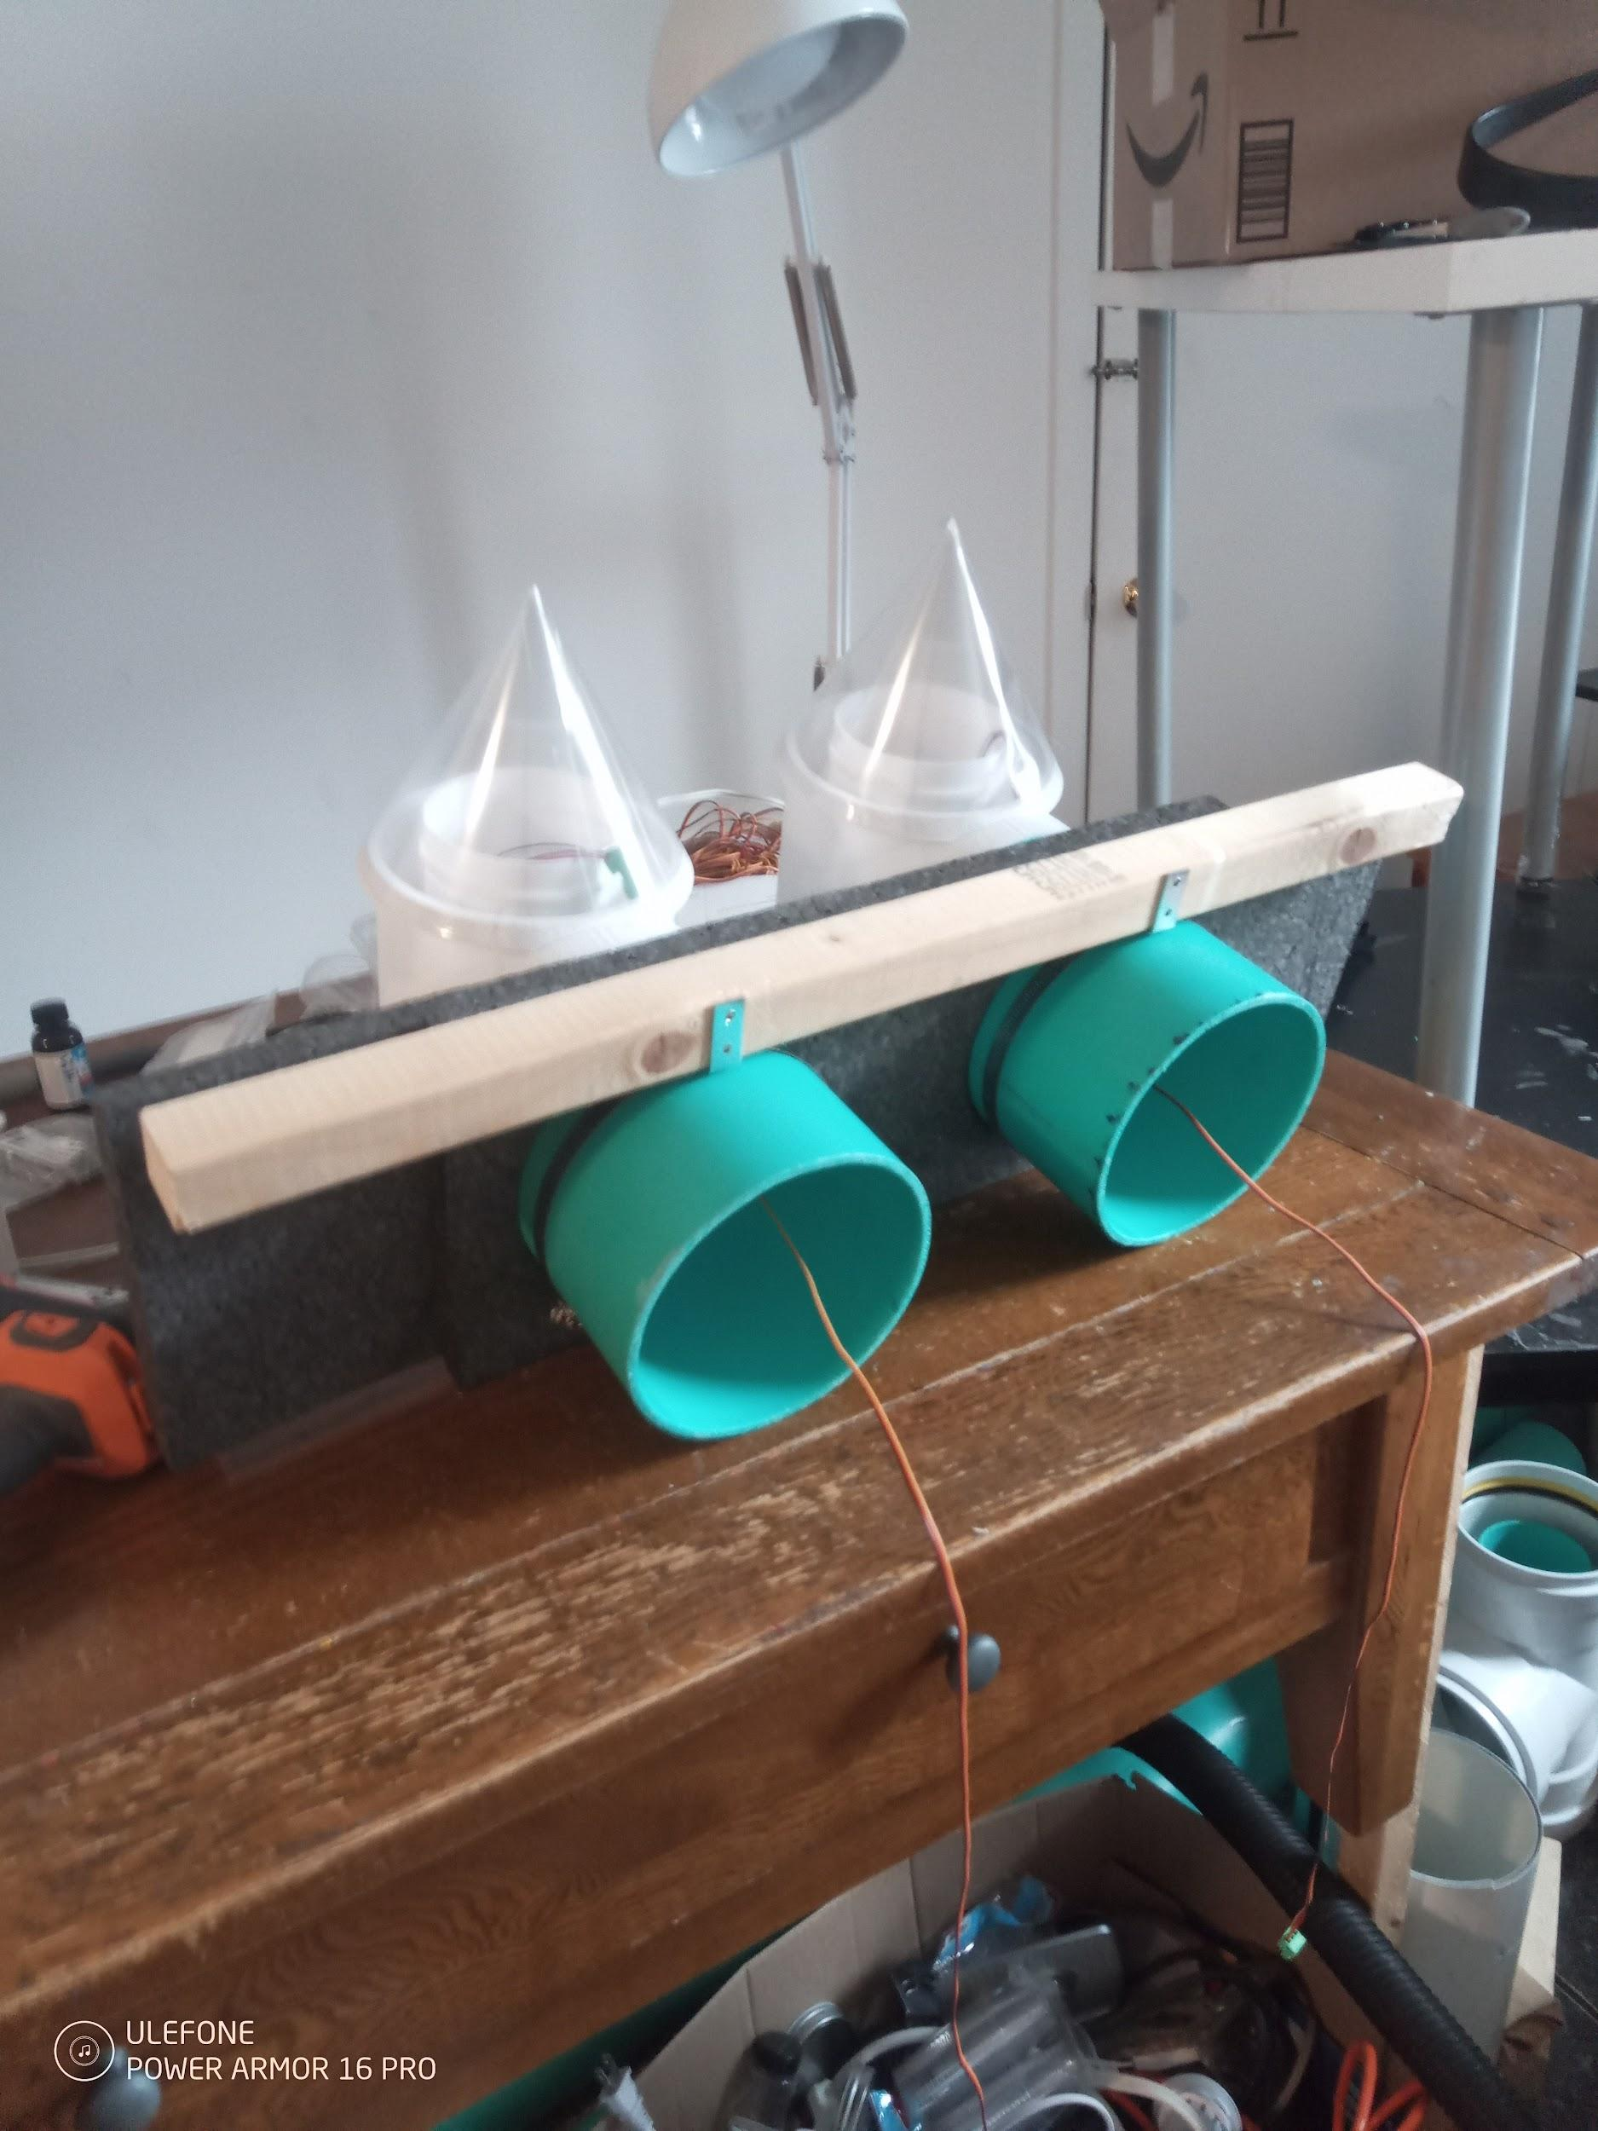
- Place the left indoor cover (the one with the silicone tube) and plate assembly near the indoor end of the pipe. Attach the cable connector Then with the notch at the top (12 o'clock position), put the silicone tube and the wire in the notch, and slide the heat exchanger into the pipe. This part is a bit tricky. You have to place the wire and silicone tube side by side in the notch of the heat exchanger, with the heat exchanger nearly in the pipe, with the tube and wires not overlapping each other. The tube and wires should not pinch or bind! Things should pretty much slide freely. If the tube gets squished, things will not work quite right.
  - Do not pull much on the silicone tube or you may pull it out of the sensor and have to open the cover and put it back in the sensor. I tape them or glue them on to the sensor to help with this but nothing sticks very well to the silicone. It’s a hassle to get the cover back on after because of the wires.
  - Notice that the heat exchanger kind of slides around freely. This is not quite ideal but I haven’t solved it yet. *when you pick up the machine, it can slide around*. So keep the machine level when you pick it up, more or less. Remember it’s supposed to be installed in a wall, not moved around like this.
- Then rotate the heat exchanger 90 degrees, ideally, to prevent any stress or pulling on the tube. There has to be enough extra wire on both ends of the heat exchanger so things don’t bind or get pulled on.
- 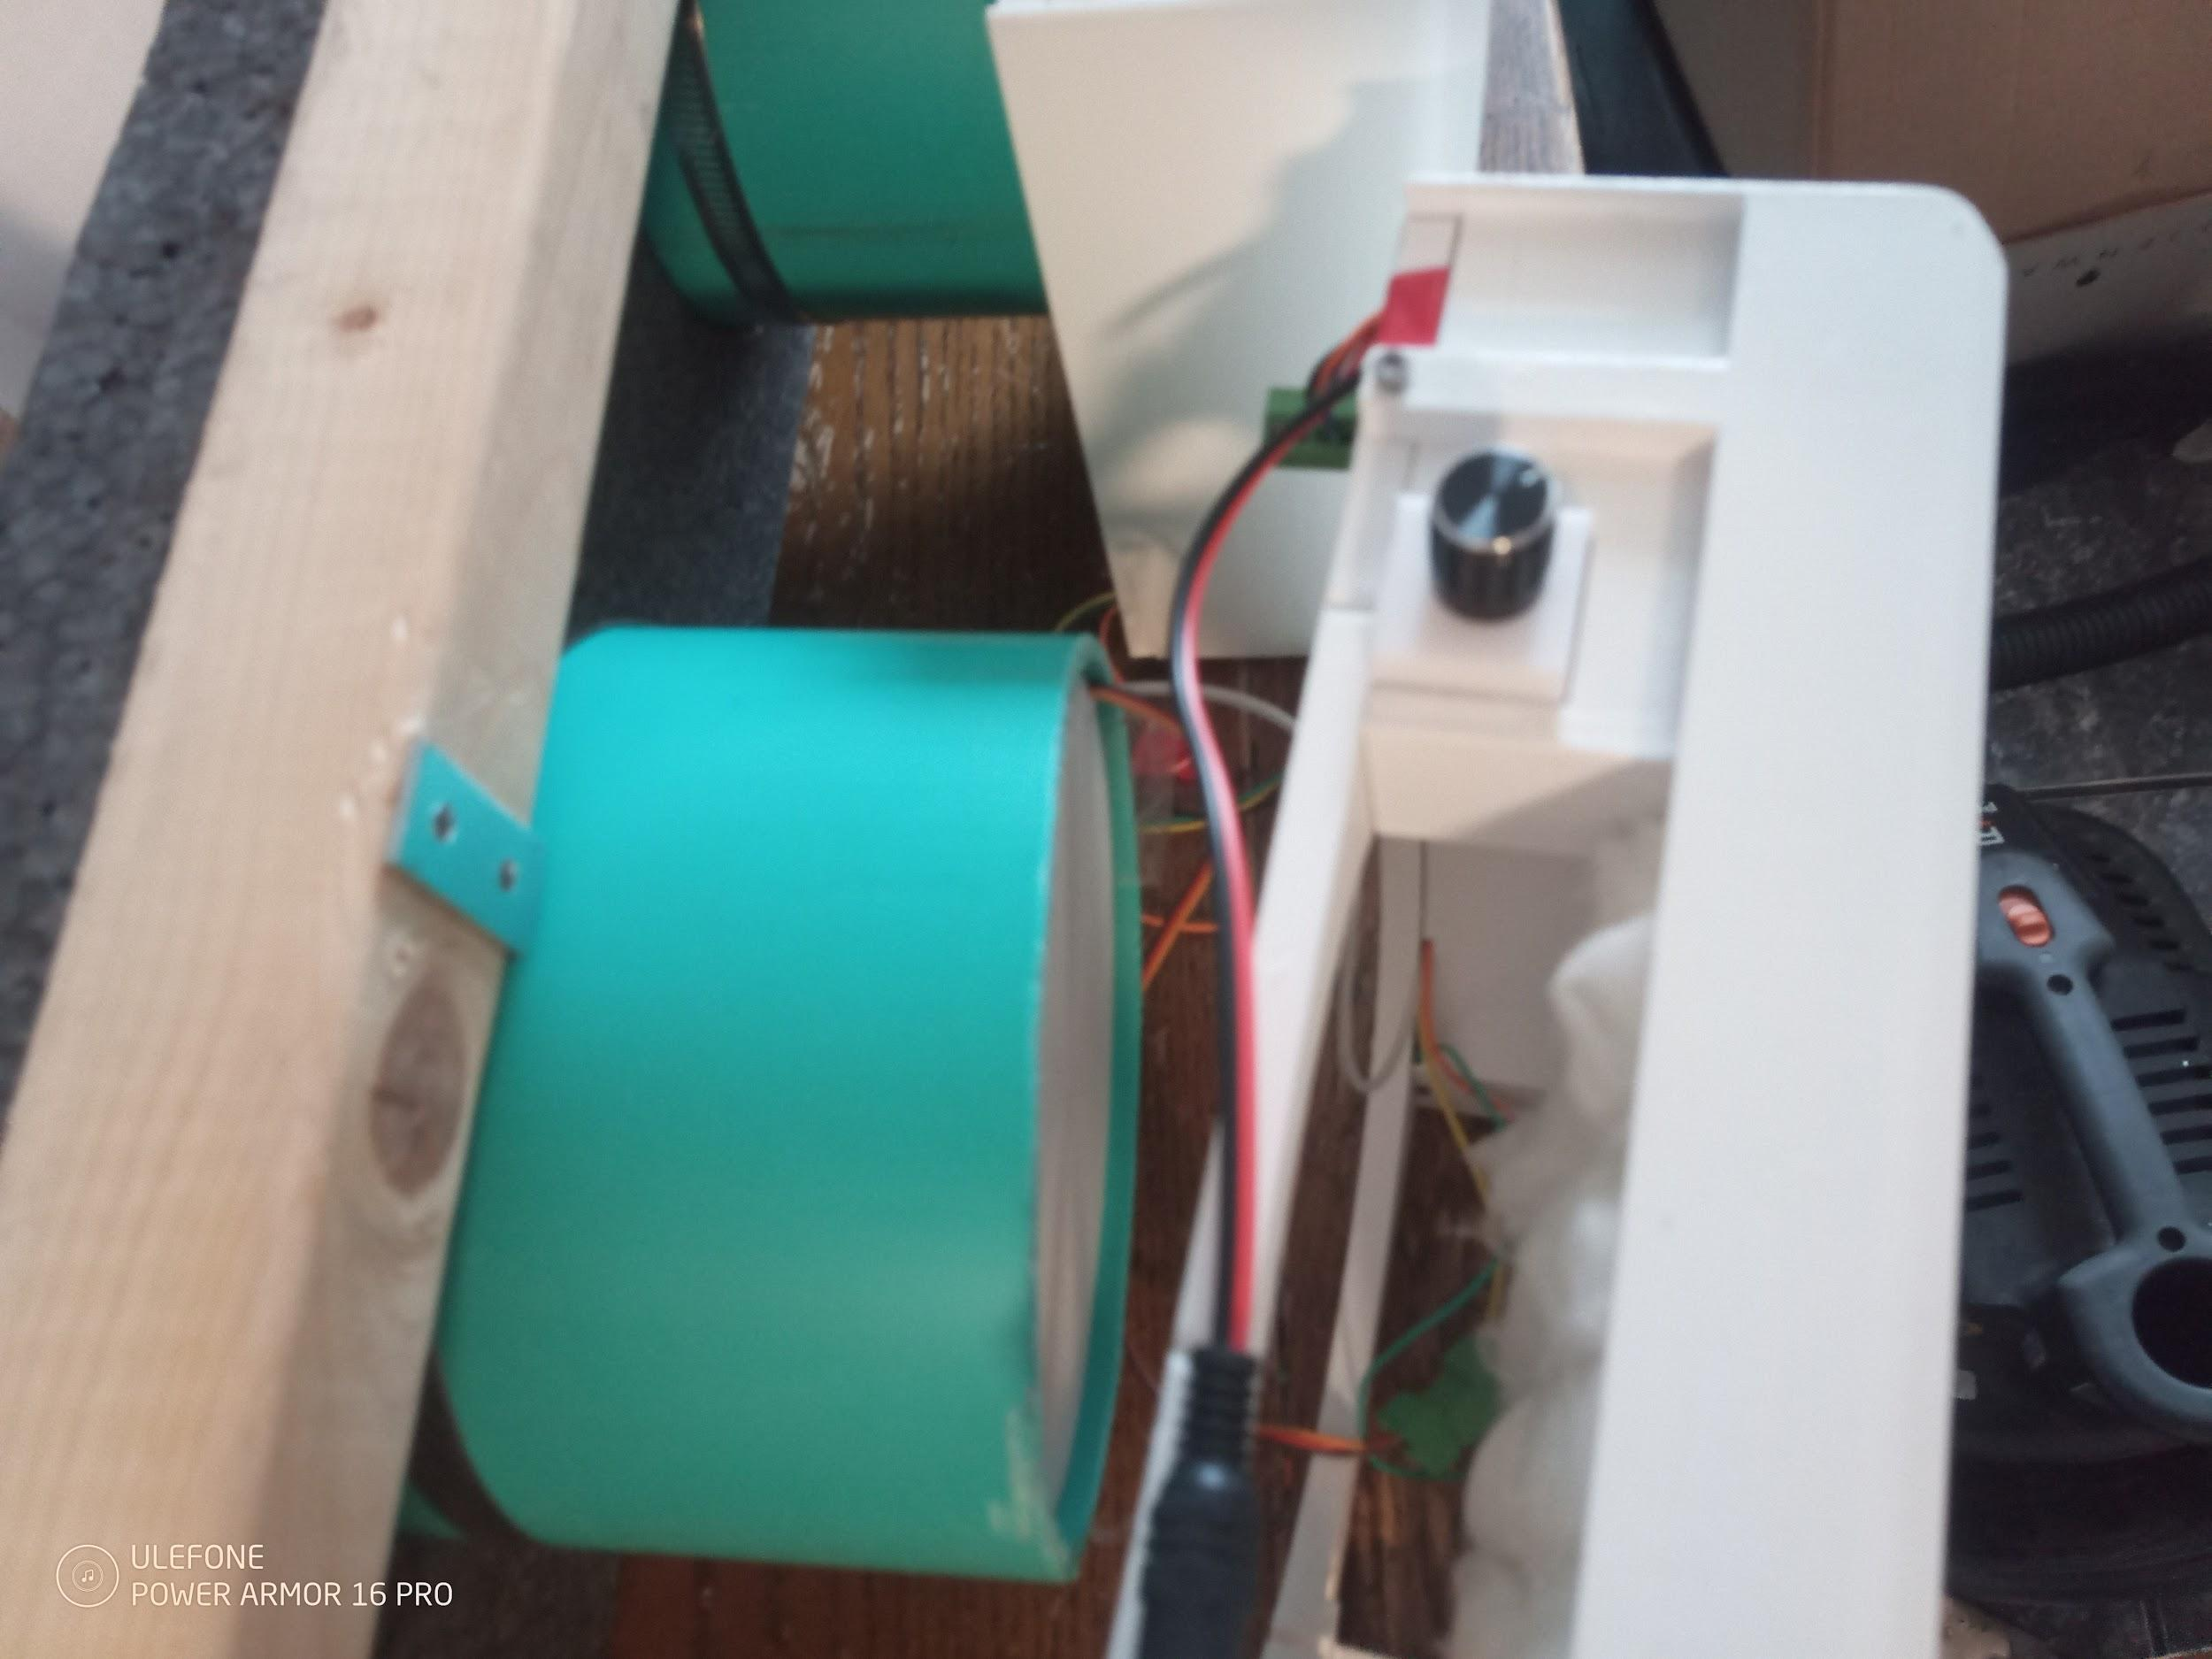
- Repeat the procedure for the left side, but you can slide the heat exchanger in first, and then plug the wires in, because there is no silicone tube to deal with.

- Now would be when you add the pipe extensions to the noise splitter, they help improve noise rejection but are optional. It makes things kind of awkward to put n the table. *Again be aware the heat exchangers can slide around inside the pipe if the machine is tilted*
- Connect the two plates together, there is a 4 pin connector that is used, behind the plates.
- Ensure the clamps are tight enough, there are 6 clamps, one on each noise splitter and one on each indoor plate, and the hose clamps around the pipes. The ones on the indoor plate I rarely tighten and they require a ball end hex driver to reach in there anyway.
- It is a good idea to power it up while it’s on the table, just to verify things seem to be working,
  - Do not work on it while it’s in the window, it’s tempting but you may push it out of the window or something. If you accidentally pull it inside the window you can knock the noise splitters off if they aren’t on properly, or break them even.
  - The table blocks the airflow unfortunately during assembly. If you can, lift up the back while it’s running and verify the airflow seems to be going the right way. Watch the behavior of the hats, that tells you if they are under negative or positive pressure. Don’t get your finger in the fan! I put a two by four underneath the rear and front in order to prop it up for testing. It’s a bit precarious like that.
- If the mylar hats have a dent in them, adjust the seating. If they collapse in that area while under negative pressure and make a noise in the process and you cannot solve it by adjusting the seating,, you can just add some gorilla clear tape to that area to prevent it from making noise when they collapse, this is a workaround for now. The thinner the mylar the better the anti noise performance so it is pretty close to the limit. The slight dent formation is otherwise perfectly harmless.

Handling/window installation

Moving the machine:
- Don’t leave the power supply connected, disconnect it every time you move the machine, to simplify things.
- If the wooden window timber retainer is assembled correctly, it can be used as a handle to pick up and move the machine. Ensure the clamps are reasonably tight before picking it up.
- If the machine is tilted during motion or knocked around, the heat exchangers may slide around. Try to keep it more or less level to avoid this.

Plan each move, make sure there is nothing to trip over etc.

If anything doesn’t fit or is awkward, patiently back off, put things back, correct it and try again.

Make sure everything is properly in place and connected/tightened and so on so nothing is going to fall off and plummet downwards, on the outdoor side especially.

Adjust the position of the wooden window retainer before putting it in the window. Don’t loosen the hose clamps while it’s in the window to adjust the position, tempting as it may be, you may end up dropping something out the window.

Do not pull the pipes/unit inwards while the unit is in the window, if the outdoor components are not attached firmly they could be pushed off by the window sill and plummet downwards.

Normal installation in a window
You first should assemble the unit on a table, and test it to verify there are no wiring errors etc, as it’s much easier to correct things at this stage.

Ensure that the noise splitter is fully secure on the pipe, attempt to rotate them relative to the pipe to ensure they are secure. The bolt does not need to be very tight to ensure a great deal of friction. Do not overtighten the bolt or it will break the clamp.

Ensure the indoor cover(s) is/are reasonably secure, and also it’s very important the hose clamps are secure around the pipes.

Check things can fit in the window. This is not so easy, you may need to use a measuring tape, and if you can, open the window wide and lift up the unit (after full assembly is completed) and see if it mostly fits. Sometimes the noise splitters hit the window sill. If this occurs, a 2 by 2 can be put on the lower part of the window to raise the assembly but it is a hassle to seal everything.

You can change things in some ways, such as by rotating the noise splitters so that things fit.

Don’t worry if you crumple the mylar hats a bit, it appears to be harmless.

After you have a sound plan, you can trim the extra included black polypropylene foam, tape it to the other foam, and move it into position, close the window, and put the window restrictor clamp in place.

I usually close the window around the pipes themselves, with the foam overlapping on the interior side, as I have found it easier to seal like this.

It appears to be a good idea in some cases to tape the timber to the foam, as it makes it easier to seal all gaps later around the window, when this is done. It’s hard to get tape in there when it’s installed in a window.

You can lift the unit safely by grabbing the timber, when the hose clamps are secure, the only remaining problem is the heat exchangers can slide around if they are not a tight fit. Making them a tight fit makes things harder sometimes so the best thing is to keep the unit level at all times and make sure the interior covers are secure against the pipes so if they do slide around it doesn’t knock the covers off and tumble out.

The next unit I ship will have a different timber, shorter, with metal pieces (“mending plates”) extending off the end, to make shipping cheaper, as the long timber was expensive to ship. You will measure your window and screw the metal pieces in place such that the total length of the metal pieces and the timber is slightly longer than your window is wide. Thus it is practically impossible for the unit to fall out the window in landscape mode.

If you need it to be longer because you have a very wide window, you may need to purchase a timber locally from the hardware store and cut it, then attach it with a screwdriver (robertson, #2 I think, the green one), depending how secure you want it to be.

I recommend taping the edges of the foam and window shut with gorilla clear tape or similar. Otherwise strong winds can blow significant amounts of air through even small cracks. You don't generally want to remove it very often. It doesn’t look great but I see no other way to really seal things easily.

Access to the outdoor side is useful for various reasons, to inspect etc. It can be an awkward fit due to the sill on some windows, usually the outdoor sill, but I have been able to shimmy it into every window I have tried thus far.

- There should be a small metal clamp like object included in the package. This is the window restrictor. You clamp it to the window in some area to prevent the window from opening too widely, which could allow the machine to fall out. Strategize for when and how to add this before putting the unit in the window.

Just like a window air conditioner you should be very careful:
- Be extremely careful not to allow the machine to fall out the window. The timber across the top plus the mending plates is supposed to be long enough that it is quite hard for it to accidentally go out the window.
- You may find that the exterior part hits the outside window sill/the exterior wall. If this happens you may need to remove the extra little green pipes or not add them, or you can raise the unit up by putting a timber below it, in the window. Most people don’t add them although the 45 dBa at max power is with them, not without them. The unit can rest on the exterior window sill and the foam still seals and everything works fine, in my experience.
- Do not try to move the unit with the power attached, it gets awkward and looks like it would considerably increase the possibility of accident. Also you could break something if you pull too hard on the power cable. Unplug the power supply and otherwise simplify things as much as you can before moving the device.
- You can use the timber across the top as a handle to move it around. Again, try no to tilt it because the heat exchangers can sometimes currently slide around relatively easily, I have no good solution to this yet.
- Remember when you turn it on that 60 cfm is a lot of air as ERVs go, it’s as much as some full sized centralized units get during cold weather. If it seems a bit loud on max, that’s because it’s a lot of air and power, not because the machine is inherently noisy. It has an excellent noise to flow/efficiency relationship, however it also has a relatively high maximal power capability.

Sideways installation
It is possible and practical to install the machine sideways. Below are some candid photos of an actual installation.
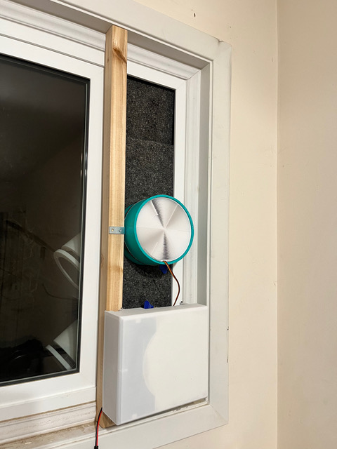
In this photo, the interior cover is oriented in a way such that the air would come out the side and get re-inhaled by the other heat exchanger. I recommended putting some tape over the outlet on that area.
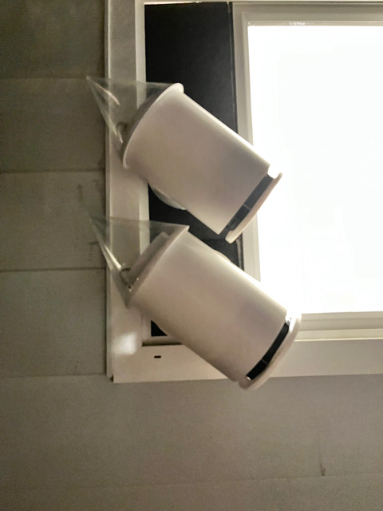
The noise splitters are rotated to get them to fit despite the window sill. Theoretically longer pipes could also work, or a timber as a spacer.
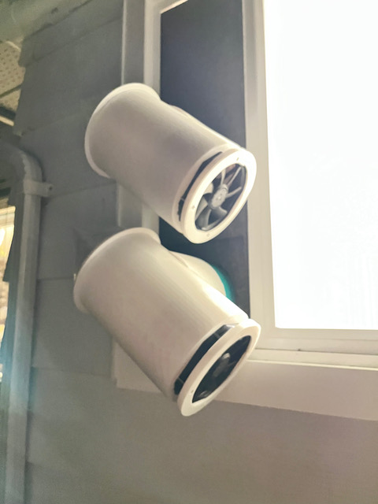

Repair and maintenance:

Overview
The system is made to be maintained over the very long term, thus giving good return on investment. The wiring is the hardest part, the schematic is pretty simple as such things go but it is easy to put a wire in the wrong place, or allow a stray strand of the multi core wire to touch the wrong place (this is a common issue so watch for it. Always twist the multiple strands around each other before inserting in a connector to avoid this).

The electronics are all standard and basic, except the pressure sensor. The connectors are relatively user friendly. In the event of power surges, angry exes, etc. any damaged component can be replaced, even if the original company is gone. 50% of home improvement companies are out of business within 5 years, so warranties are not enough.

Fan replacement and/or bearing replacement:
Any 120 mm fan can be used, 2, 3 or 4 pin, you just need to cut the corners off. The main issue is getting a fan that is quiet, and water resistant, and ideally ball bearing, and high pressure. If you cannot get waterproof fans, silicone waterproofing grease (such as marine dielectric grease, which is used on ships to waterproof electronics) can be painted with a brush onto the electronics of almost any ball bearing 120 mm fan. These fans can be dismantled just by removing the sticker on the back and removing the circlip (small torx screwdrivers work to remove the circlip). There are waterproofing sprays for electronics that could be simply sprayed in there, but they are not common and I have tried only one with limited success. Silicone oil is basically what you’d want. Mineral oil would probably work fine too.
The printable components can be printed by any cloud printing company, or ideally a real person who just has a printer in the local area, which tends to be a lot cheaper (makexyz.com is one option).

The included fans can have their bearings replaced, and the bearings should last 7-12 years. The bearings cost only about 20 cents each and are widely available, standard bearings.

Bearing replacement instructions:
Bearing size: OD: 8 mm. ID: 3 mm. Thickness: 4 mm.(3x8x4 bearing). If you search 3x8x4 bearing you will see a lot of people selling them in small quantities. The ABEC rating and noise level doesn’t really matter much, in any case small time sellers usually claim more than is true, unless you are actually buying from mcmaster-carr or directly from a supplier.
The circlips: Are 3 mm outer diameter circlips. You may not need to buy one, you can usually re use the old one, but if you lose it or break it you can get replacements easily, get the kind with the little hooks or complete holes on the end, ideally. Alloy is fine, stainless is overkill.

You need to dismantle the system to get the fan on a table in front of you, then remove the sticker covering the bearings, remove the circlip, and the fan blades/magnet assembly just falls right out. The bearings just fall out, you put the new bearings in and then put the circlip back on.

To remove the circlip is the hard part. Circlip pliers of the right size are hard to get and expensive, however I have found a good technique using two very small torx screw drivers. You need 1-0.8 mm or smaller torx heads. Place the two screw drivers together and push down while levering them against each other (the handles of the screwdrivers make a usable fulcrum point, you can tape them together to make it a little easier) to cause the tips to spread apart. The bearing has a spring behind it, when the circlip is released the bearing will pop up. The circlip may also sproing away and be lost, so be ready.

Putting the circlip back on is a bit difficult. You can finagle it back on with the screw driver, I’ve found that to be workable, but an even easier way is to drill a 3 mm hole in the end of a 7 mm diameter hot melt glue gun refill. It’s basically a soft polymer rod. The hole squeezes over the shaft, but the edge of the hole pushes the circlip down nicely, until you feel it click into place. You only have to do this every 7-12 years!

Electrical schematic:

The colors in the schematic should be the actual wire colors. Beware red is used for both 5v and 3.3 volts. !2 volts is Yellow. Black and brown are ground. Orange is for the ingress fan, green is for the egress fan, both the signal to the mosfet board and the ground side of the fans. Orange and green is also used for the pressure sensor data and clock signals, which is which is in the schematic.
The part descriptions for electrical parts are in the BOM.
There is a PDF in the source code repository with the schematic, it is not copied here because it’s too laborious/unreliable to make sure the various copies are always up to date if there is a change or bug correction. You have one copy in one place and then refer to it as needed. When things are out of beta it will be copied here.

STL files for replacement printable parts:
See source code repository. It’s a google drive linked to on the website, and will be put in the internet archive for long term if possible.

Note on printing the regenerator/heat exchanger:
The latest and greatest heat exchanger is produced directly with python script generated gcode specific to the printer I use and cannot be practically produced diy, unfortunately. However the old model can be, and the STL is included for that, in the source repository. To do this, simply use Cura, load th STL in, put it in the center of the build plate, and set it to do “lines” infill with about 2.5 mm on center (between centers of the lines) spacing and 0.45 mm width, no top layer and no bottom layer (set them to zero). Check the preview and it should show you a structure which is much like grid infill, parallel channels which are square in cross section, with the outer wall. Tape can be applied over the nubs on the side to fit in an oversized pipe, or they can be sanded if the pipe is too small. You could also use grid infill, but the roads tend to have problems where they intersect. When the nozzle goes over one road, it wipes the plastic off, and not enough is deposited on the lee side. I don’t know how to solve this in Cura without using lines infill. If you could make it so the nozzle went in alternate directions each layer that would probably solve it well enough.

Replacement part numbers/sourcing:
The connectors are called pluggable screw terminal connectors, 3.81 mm pitch.
The screws are stainless steel self tapping screws hex socket stainless steel 304.
The part number of the fans is 11925SE-12R-FT-DW . They are available from digikey and other electronic parts overnight supply houses.
The plastic sheet for the hats is 50 micron generic BOPET, biaxially oriented polyethylene terepthalate, (generic mylar, mylar is a brand) but 75 micron (3 mil) might be a better bet, some 50 micron is crinkly and makes noise.
The adhesive is E6000, waterproof elastomeric adhesive.
The wire is silicone multi stranded wire, 24 gauge is fine for repair stuff.
The pipe is SDR35 PVC pipe, SDR28 will NOT fit SDR35 ABS is *not* the same size.
The thin transparent tape is gorilla clear.

Efficiency:
Testing is ongoing, initial testing results indicate 87% sensible heat recovery efficiency at 60 cfm and 75% latent heat recovery. Efficiency is even higher at lower flows, exceeding 90 percent at 30 cfm.

Ventilation efficiency/short circuiting:
There is a measure in the HVAC industry/building design called ventilation efficiency. It’s basically the ratio of the indoor air quality vs the ventilation rate, or the indoor air pollution vs ventilation rate, assuming a constant release of pollutants in the building. There are many clever ways such as displacement flow ventilation, to improve this above the basic so called dilution flow approach, which is the normal approach commonly used, where a jet of air just swirls around in a room and mixes thoroughly, and air is removed practically randomly from the room. One thing that puts a dent in ventilation efficiency is so called short circuits, which is a bit of a misnomer, but it it implies fresh air transiting rapidly to the exit/exhaust, without doing anybody any good.

Obviously the WM12 has the intake and the exhaust right next to each other, but they are pointed in opposite directions. I have used smoke to viualize airflow and posted a video of this on youtube. There is no re-inhalation of air near the unit. The exiting air jets away and mixes into the room effectively.

The only case where there is a significant although minor concern is when the unit sticks over a window ledge, in that case some air at the bottom near the ledge tends to swirl back in. To solve this, a piece of paper or cardboard can be used to guide the airflow.

Savings/investment calculations:

See spreadsheet here, it is also linked to on the website, to determine the actual return on investment that applies to you, in your area, with your energy prices. The machine is an investment, its value arises from long term operation.

Specifications:

Spec | Value
Max actual net fresh air flow | 60 CFM
Power supply voltage | 12 Volts
Power supply current requirement | 1.5 Amps max (during fan acceleration)
Expected actual average season-round efficiency at 60 cfm, including water vapor/latent heat if silica gel coated. Varies little with conditions. | 87%
Expected actual average season-round efficiency at 30 cfm including water vapor/latent heat if silica gel coated. Varies little with conditions. | 90%
Noise emission at 1 meter in front of unit, at 15 CFM | 30 dBa
Noise emission at 1 meter in front of unit, at 30 CFM | 35 dBa
Noise emission at 1 meter in front of unit, at 60 CFM, with optional extra pipe segments | 45 dBa
Wind resistance rating (from in-house measurements, not yet certified) | S1 (less than 6 CFM at 20 pascals wind pressure, total excess flow in or out). It’s actually better than this.
Average power consumption at 60 CFM | 9 Watts
Average power consumption at 30 CFM | 5 Watts
Design life | Parts can be replaced indefinitely.
Fan bearing life span, expected | 7-12 years elapsed time during normal use
CE mark certification | Not yet.
Underwriter’s laboratory certification | Not yet, the power supply is UL listed, though.
Rohs compliant.
Contains no toxic or hazardous materials.
Made in freedom.

